Lab03: Classification and Regression Prediction Models

**Handed out:** Wednesday, March 8, 2023

**Return date:** Friday, March 24, 2023, at the eLearning link **Lab03Submit** in the **Lab03** folder.

**Objectives:** Comparison of different classification as well as regression tree models and the evaluation of their predictive properties.

**Grades:** This lab counts 9 % towards your final grade

**Format of answer:** Your answers (statistical figures and verbal description) should be submitted electronically as Word document. Add a running title with the following information: Lab03, your name and page numbers. Use this document as template: add your answers for each subtask, i.e., 1 (a) etc., in a red color as well as any requested statistical figures. Trial and error answers will lead to a deduction of points. You are expected to hand in professionally formatted answers: use a fixed pitch font, like **Courier New**, for any Picture 8 code and output.

Part 1: Classification trees [6 points]

You will be using for this part the dataset **mushrooms.csv** and split it into a stratified ***training*** data-frame with 2/3 of the observations and ***test*** data-frame with 1/3 observations. The dependent variable is **type**. Remove the variable **veil_type** with **mushrooms$veil_type <- NULL** because it is constant over all observations.

**Task 1:** Build a classification tree, properly prune the tree, and interpret the pruned tree. Show both the pruned and unpruned trees. Use the ***training*** data-frame. [1 points]

**Task 2:** Build a predictive model using the **randomForest** function with bagging based on the parameter **ntree**. Evaluate the relevance of the features. Use the ***training*** data-frame. [1 point]

**Task 3:** Build a predictive random forest model using the **randomForest** function and find the optimal hyper-parameter **mtry** for the number of features explored at each steps. Use the ***training*** data-frame. [1 point]

**Task 4:** Build a predictive boosted tree model using the function **gbm** and find the optimal depth hyper-parameter **interaction.depth**. Use the ***training*** data-frame. [1 point]

**Task 5:** Compare the models from tasks 1 to 4 for the ***test*** data-frame by using their **ROC** curves, the **auc** statistic, their prediction error rate and their overall node purity. Justify which model you would use to avoid mushroom poisoning. [2 points]

rm(list=ls()) # Clear environment

oldpar <- par() # save default graphical parameters

if (!is.null(dev.list()["RStudioGD"])) # Clear plot window

dev.off(dev.list()["RStudioGD"])

cat("\014") # Clear the Console

library(tree)

library(ISLR2)

library(caret)

library(randomForest)

library(gbm)

library(caret)

# Load the dataset

mushrooms <- read.csv("/Users/jimpan/Documents/EPPS 6326/lab/lab3/mushrooms.csv")

# Remove the variable veil_type

mushrooms$veil_type <- NULL

# Convert non-numeric columns to factors

non_numeric_cols <- sapply(mushrooms, is.character)

mushrooms[, non_numeric_cols] <- lapply(mushrooms[, non_numeric_cols], factor)

table(is.na(mushrooms))

table(mushrooms$type)

# Remove rows with missing values

mushrooms <- na.omit(mushrooms)

# Split the dataset into training and test sets

set.seed(1)

train <- mushrooms[1:round(2/3*nrow(mushrooms)),]

test <- mushrooms[-(1:round(2/3*nrow(mushrooms))),]

summary(train)

train <- na.omit(train)

#Q1

# Build an unpruned tree using the training data

tree_mushrooms <- tree(type ~ ., data = train)

summary(tree_mushrooms)

plot(tree_mushrooms)

text(tree_mushrooms, pretty = 0)

## Deviance: -2 * sum_Classes(sum_Nodes(obs_CN * log(phat_CN)))

tree_mushrooms

## Pruning

set.seed(1)

help("cv.tree")

cv.mushrooms <- cv.tree(tree_mushrooms, FUN = prune.misclass, K=10)

str(cv.mushrooms)

cv.mushrooms

par(mfrow = c(1, 2))

plot(cv.mushrooms$size, cv.mushrooms$dev, type = "b")

plot(cv.mushrooms$k, cv.mushrooms$dev, type = "b")

par(oldpar)

## Evaluate pruned tree

prune.mushrooms <- prune.misclass(tree_mushrooms, best = 4)

plot(prune.mushrooms)

text(prune.mushrooms, pretty = 0)

# Q2

# Build a random forest model using the training data

rf_mushrooms <- randomForest(type ~ ., data = train, ntree = 500)

## Importance plot

varImpPlot(rf_mushrooms)

#Q3

table(is.na(train))

train <- na.omit(train)

# Find the optimal mtry

tune_mushrooms <- tuneRF(train[, -1], train[, 1], ntree = 500)

tune_mushrooms$mtry

#mtry = 4 OOB error = 0%

#Searching left ...

#mtry = 2 OOB error = 0%

#NaN 0.05

#Error in if (Improve > improve) { : missing value where TRUE/FALSE needed

#Q4

set.seed(1)

## Find the optimal interaction depth

depths <- 1:10

errors <- rep(0, length(depths))

for (i in 1:length(depths)) {

boost_mushrooms <- gbm(type ~ ., data = train, distribution = "multinomial",

n.trees = 5000, interaction.depth = depths[i])

errors[i] <- boost_mushrooms$cv.error[boost_mushrooms$n.trees == 5000]

}

## Plot the cross-validation error rates

plot(depths, errors, type = "b", xlab = "Interaction Depth", ylab = "CV Error Rate")

#Q5

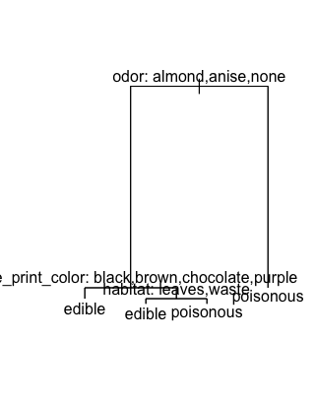

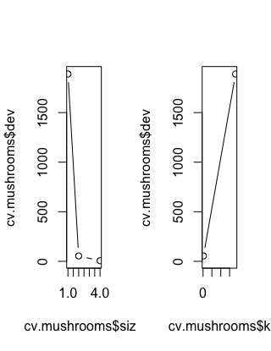

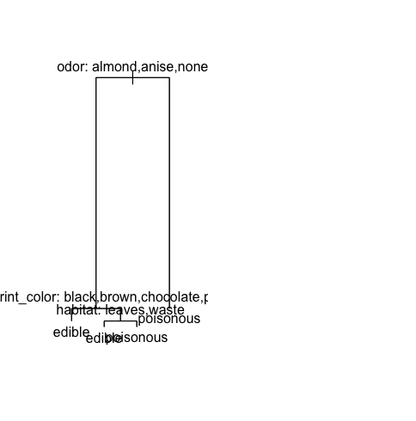

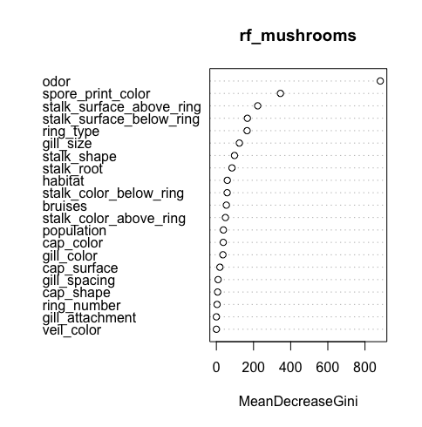

Part 2: Regression trees [3 point]

You will be using for this part the dataset **redwines.csv** and split it stratified with just 3 matching strata into 2/3 ***training*** data and 1/3 ***test*** data. The dependent variable is **quality**.

**Task 6:** Build a pruned regression tree with all feature variables and interpret the pruned tree. Show the pruned and unpruned trees. For model calibration use the ***training*** data-frame. Calculate the model fit for the ***test*** data-frame. [1 point]

**Task 7:** Calibrate for the ***training*** data-frame with all feature variables a random forest model and identify its optimal hyper-parameters **ntree** and **mtry**. Evaluate the variable importance. Calculate the model fit for the ***test*** data-frame. [1 point]

**Task 8:** Calibrate for the ***training*** data-frame with all feature variables a boosted model and identify its optimal depth hyper-parameter **interaction.depth**. Calculate the model fit for the ***test*** data-frame. [1 point]